Touchy Subjects
Concept Product Line Sheet + OpenSCAD Design Pack
Prepared for Rochelle Berry
Parametric concept files included for wearable grip, bottle grip, and discreet emergency-carry capsule products.
Slate | Copper | Sage | Purple
Positioning: tactile utility objects that feel reassuring, look intentional, and live comfortably between assistive product, wearable object, and everyday design accessory.
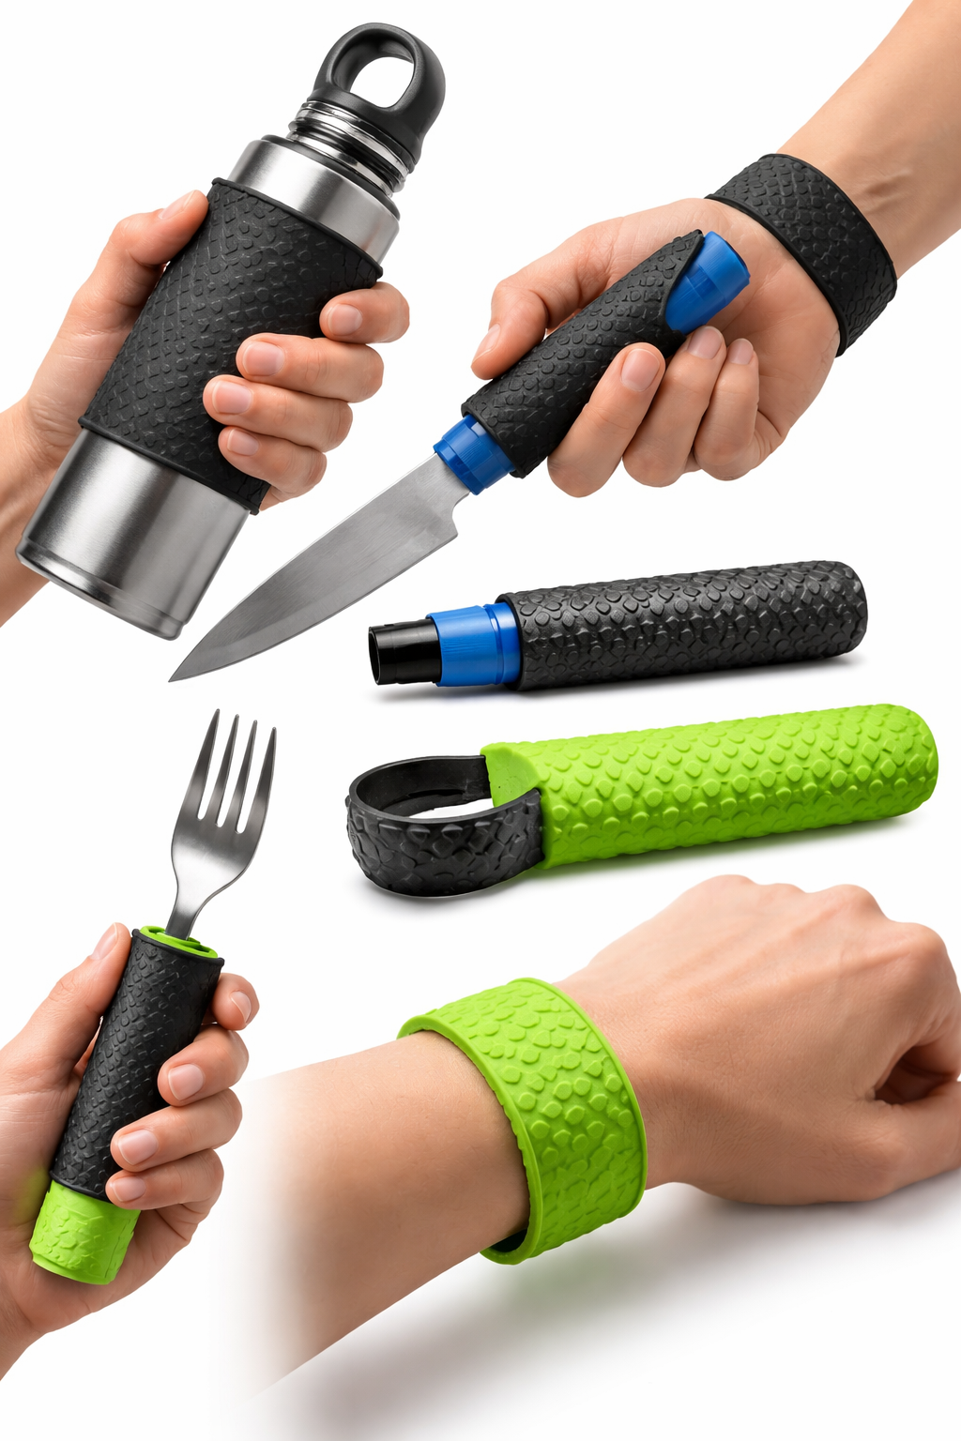  GripWrap bracelet: wearable grip accessory that stores flat and snaps into conforming use. | 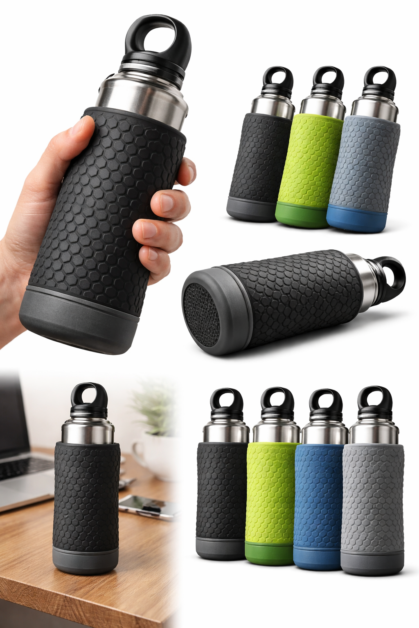  Bottle Halo sleeve: thick tactile wall, strong grip texture, and integrated coaster base. | Included concepts  • GW grip bracelet family  • BH bottle sleeve family  • DH pill pendant family  • Shared helper library  • Packaging + SKU matrix  • Texture system

1. Product Architecture
The line naturally separates into three families: wearable grip, vessel grip, and discreet emergency carry. The shared design language should be rounded, tactile, and reassuring rather than aggressively technical.
• Wearable grip objects should prioritize hand-feel, immediate understanding, and flexible deployment.  • Bottle accessories should reduce effort while also adding style, sound damping, and table protection.  • Pendants should read as jewelry or personal object first, with the storage role kept discreet. | 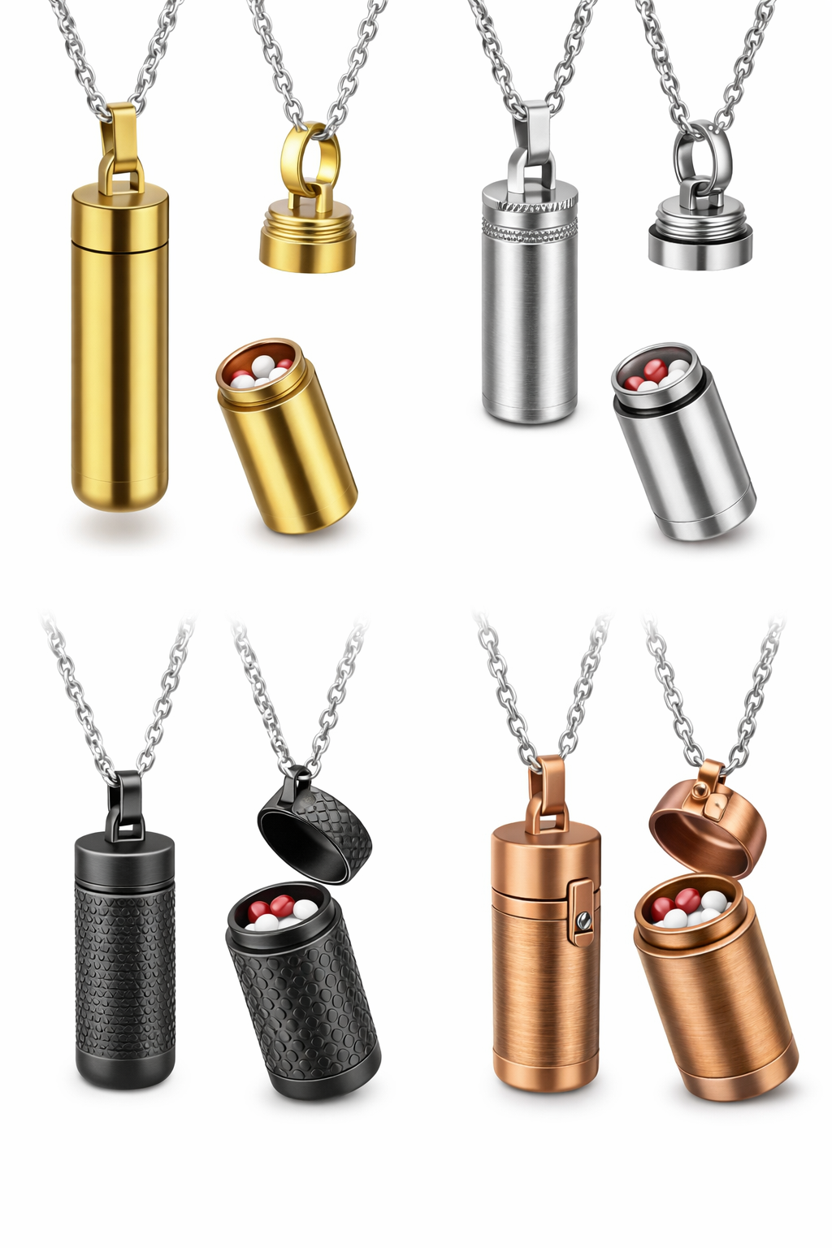  Dose Halo pendant family: discreet jewelry-style capsule with multiple closure directions.
Family | Hero SKU | Use case | Recommended textures
Wearable grip | GW-101 GripWrap | Snaps from bracelet mode into a hand-held grip aid for utensils, tools, or bottle necks. | Pebble, topo, guide-ridge
Bottle accessory | BH-201 Bottle Halo | Sleeve/cozy/coaster that tightens the feel of a bottle and adds graspable volume. | Hex-dimple, pebble, topo
Medication carry | DH-301 Dose Halo | Pendant capsule for a few emergency pills when the bottle is not nearby. | Smooth satin, pebble, fine knurl

2. SKU Matrix
SKU | Product | Closure / fit | Primary material direction | Notes
GW-101 | GripWrap | Spring-steel insert channel | TPU overmold + steel strip | Hero wearable grip band; bracelet mode when idle.
GW-111 | GripWrap Calm | As above | Soft-touch TPU | Smoother topographic rib texture for lower stimulation.
GW-121 | GripWrap Focus | As above | TPU with raised guide zones | Deeper finger guidance and thumb cue.
BH-201 | Bottle Halo | Compression-fit inner ribs | TPU or silicone | Main sleeve with coaster base and anti-slip foot.
BH-211 | Bottle Halo Flex | Split seam expansion | TPU | Fits a broader bottle range.
BH-221 | Bottle Halo Loop | Compression-fit + carry ridge | TPU | Adds finger-loop ridge or clip point.
DH-301 | Dose Halo Thread | Threaded cap | PETG / machined metal direction | Most conservative and seal-friendly closure.
DH-311 | Dose Halo Turn | Bayonet quarter-turn | PETG / resin / machined metal | Faster access and stronger product personality.
DH-321 | Dose Halo Flip | Hinged latch | Resin / molded polymer | Quick-open concept with side latch language.

3. Texture System
Texture should do more than decorate. Each pattern should communicate a sensory setting and improve friction in a distinct way.
Texture | Best on | Feel | Brand use
Orbit Pebble | GripWrap / Dose Halo | Rounded, soft, reassuring micro-bumps | Best signature texture for the overall brand.
Topo Ripple | GripWrap Calm / Bottle Halo | Gentle ridges with directional flow | Premium, calm, less clinical; ideal for your slate/sage palette.
Hex Dimple | Bottle Halo | Technical, secure, wet-hand friendly | Strong retail read; good for active and kitchen settings.
Guide Ridge | GripWrap Focus | Finger steering + thumb cue | Useful for assistive positioning and one-handed grasping.
Fine Knurl | Dose Halo Thread | Sharper tactile confidence | Use sparingly as a closure cue instead of full-body texture.

4. Packaging Direction
Packaging should feel like a design object rather than a medical accessory. Use calm typography, tactile wording, and simple instruction hierarchy.
Package format | For SKUs | Front callout | Back-panel elements
Slim hanging card + window band | GW | Wearable grip, ready when you need it. | How bracelet mode works, fit examples, material note, care icons.
Sleeve belly-band + kraft carton | BH | More grip. More comfort. Less clatter. | Bottle range, hand-feel benefits, coaster base, cleaning note.
Drawer box or jewelry card capsule | DH | Discreet emergency carry. | Closure diagram, capacity note, moisture warning, cleaning and refill guidance.
Suggested front-of-pack nomenclature:
• Touchy Subjects | GripWrap | Orbit Pebble | Slate
• Touchy Subjects | Bottle Halo | Hex Dimple | Sage
• Touchy Subjects | Dose Halo Turn | Satin Copper

5. OpenSCAD File Notes
The included SCAD files are concept-oriented, parametric starting points intended for design iteration, visualization, and test-fit prototyping.
common.scad - Shared helper modules for texture bands, faux knurling, pebbles, topographic ribs, O-ring groove, and chain bail.
slap_grip_bracelet.scad - Flat bracelet body with insert channel, comfort taper, texture options, and thumb cue.
water_bottle_sleeve.scad - Tapered bottle cavity, compression ribs, coaster base, and optional finger ridge.
pill_pendant_threaded.scad - Threaded capsule with decorative body textures and O-ring groove.
pill_pendant_bayonet.scad - Quarter-turn lock concept with bayonet pins and travel channels.
pill_pendant_hinged.scad - Quick-access hinged lid concept with side latch geometry.

6. Design Suggestions Worth Prototyping Next
• GripWrap: add a removable overmold sleeve so the spring insert can be swapped between tactile skins.
• Bottle Halo: test three inner-rib profiles - continuous ring, interrupted ring, and low-durometer gripper pods.
• Dose Halo: compare threaded and bayonet closures for one-handed opening, leak resistance, and accidental-open risk.
• System idea: build one touch language where textures, naming, and colorways match across all three families.
Colorway recommendation for the first release: Slate, Copper, Sage, and Soft Ink. Use copper as the accent rather than the default body color so the line stays tactile and grounded rather than flashy.

